Cold Water Rowing in Mystic River
Water Temps in Mystic River

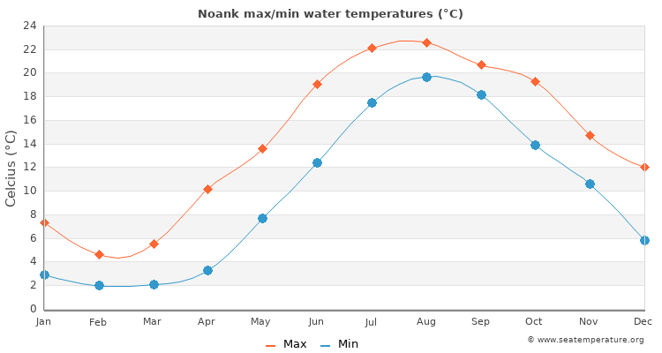
Source: Noank Water Temperature (CT) | United States Sea Temperatures
Hypothermia occurs when a victim is subject to cold temperatures, cold water, ice or snow. There is potential danger for hypothermia when the water temperature is below 80 degrees and very dangerous when the water temperature is below 50 degrees.
Hypothermia can occur without the victim being in the water, rowing in extremely cold weather can cause symptoms. Symptoms include feeling cold, turn bluish and shivering, and followed by numbness, apathy, lethargy, disorientation and loss of mental capacity.
When air is below 40 degrees and /or water below 50 degrees, keep launch within 100 yards of all shells.
NOTE: Make sure the coxswain is warm but safe. They are not moving. Many layers are not safe, if the boat flips they can drown. Mustang Survival suits are a better warming option.
What to do if cold and shivering:
- Get out of the water quickly, even on top of the capsized boat. Heat loss is 25 times greater when in the water.
- If unable to get out of the water, huddle with others. Keeping as much of the body out of the water as possible.
- Move to shelter quickly, remove wet clothing and re-warm body. In mild hypothermia conditions, re-warm in a shower, tub or with warm blankets.
- Do not give any liquids to drink, treat for shock.
- Continue to re-warm and always obtain medical assistance as soon as possible.
What to do if shivering has stopped:
- Call or assign someone to call for EMS.
- Treat as above but DO NOT RE-WARM EXTREMITIES!
If victim is no longer shivering, the torso must be re-warmed to avoid circulation of cold blood to the heart. This can kill. Wrap the victim in a warm blanket and apply heat to the underarms and groin area; wrap again in a separate blanket. Wrap each arm and leg separately to prevent rapid re-circulation of blood to the heart. Hot packs should not be placed directly on the victim, a thin layer should be used to protect the victim from burning. If possible place the victim in a sleeping bag with a warm person.
- Administer artificial respiration and CPR if necessary. Always obtain medical assistance as soon as possible.
In a situation of cold water immersion; be aware that in very cold water people have survived as long as one hour underwater. Recover a victim immediately and even though there may be no sign of life, administer CPR efforts until medical assistance is obtained.
Source: Safety Expectations Policy - USRowing

